# Pre-Reqesitue 1.IBM Cloud Services

|  |  |
| --- | --- |
| Date | 15 November 2022 |
| Roll no | 960119104001 |
| Project name | Project-Real Time River Water Quality Monitoring  And Control System |
| Maximum Marks | 2 Mks |

IBM cloud services:

The IBM cloud services are used to handle the cloud storage and function the data.

# IBM cloud services: Launch the cloud

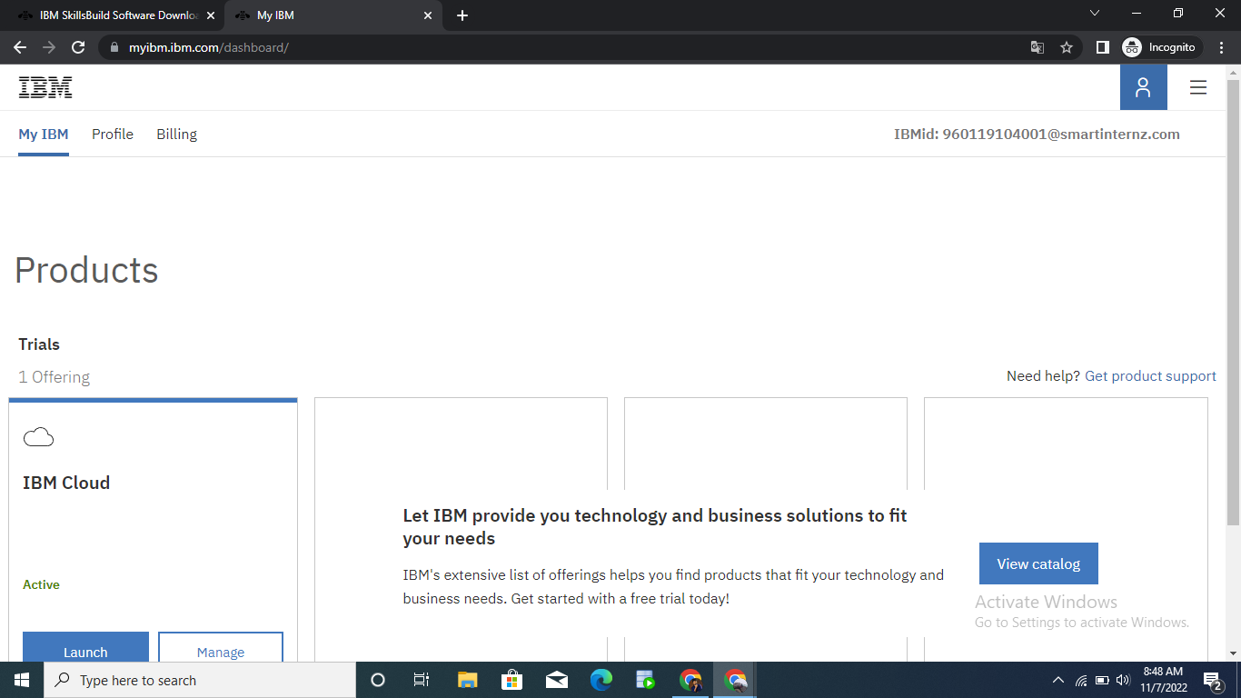

IBM cloud has been created..

